SOFTWARE REQUIREMENTS SPECIFICATION

**For**

**HOSPITAL APPOINTMENT SCHEDULER**

**Prepared by:-**

*SAI AKSHHAYAA.M.P*

*SRI SUDHI.N*

*VETRIVEL.R.S.*

# Introduction

## Purpose

## A hospital appointment scheduler serves to efficiently manage patient appointments, reducing waiting times and improving the overall patient experience. It optimizes resource allocation and enhances staff productivity by providing clear schedules. Integration with electronic health records ensures easy access to patient information for healthcare providers. Automated reminders help reduce no-show rates, and data analysis tools allow administrators to assess appointment trends. Online scheduling systems offer accessibility, enabling patients to book appointments conveniently. The system streamlines the healthcare process, contributing to a positive and organized environment. Patients benefit from timely care and can plan visits at their convenience. Staff can manage their time effectively, reducing the likelihood of overbooking. The scheduler facilitates a comprehensive view of patient history, promoting continuity of care.

## Document Conventions

* + - Entire document should be justified.
    - Convention for Main title

Font face: Times New Roman Font style: Bold

Font Size: 14

* + - Convention for Sub title

Font face: Times New Roman Font style: Bold

Font Size: 12

* + - Convention for body

Font face: Times New Roman Font Size: 12

## Scope of Development Project

Hospital appointment schedulers streamline operations, improving efficiency and minimizing patient wait times. Patients benefit from stress-free and convenient appointment scheduling experiences. These systems facilitate effective resource allocation, ensuring timely and appropriate care for each patient. Automated reminders contribute to better appointment adherence by reducing patient no-show rates. Online scheduling features enhance patient accessibility, allowing convenient booking from any location. Data analysis tools aid administrators in making informed decisions and resource planning based on appointment trends. Integration with electronic health records ensures a comprehensive approach to patient care. Staff productivity is increased as scheduling systems help manage time efficiently and reduce the risk of overbooking. Overall, appointment schedulers play a crucial role in optimizing healthcare services, benefiting both patients and healthcare providers.

## Definitions, Acronyms and Abbreviations

JAVA -> platform independence SQL-> Structured query Language ER-> Entity Relationship

UML -> Unified Modeling Language

IDE-> Integrated Development Environment SRS-> Software Requirement Specification

## References

* + - Books
    - Healthcare Operations Management by James R. Langabeer
    - Introduction to Healthcare Quality Management by Patrice L . Spath
    - Website
* **http://ebookily.net/doc/srs-hospital-appointment-scheduler/**

# Overall Descriptions

## Product Function

Entity Relationship Diagram of Hospital Appointment Scheduler

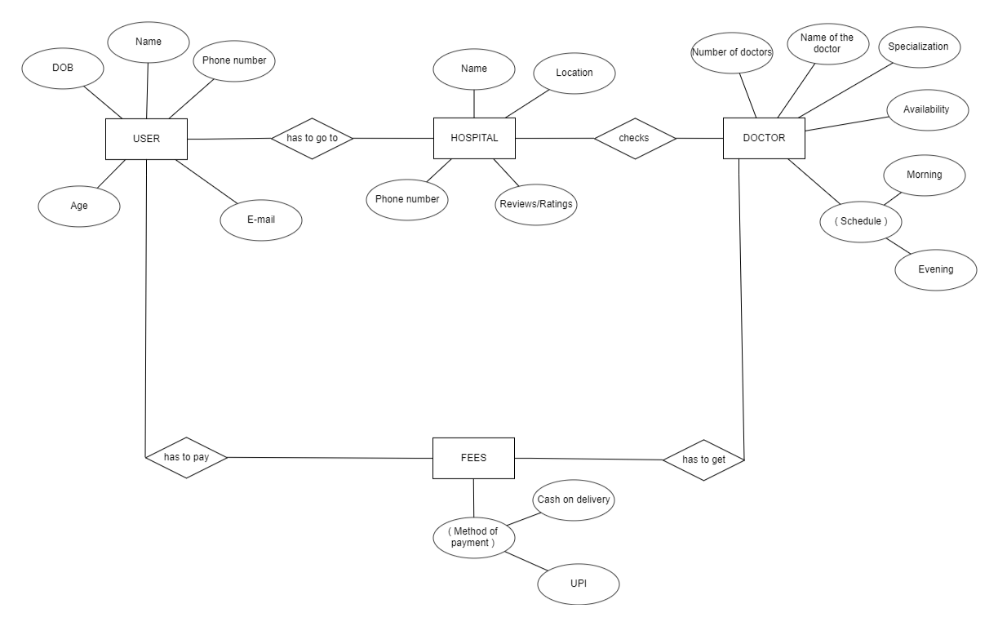

The Online Hospital Appointment Scheduler provides real-time information about available appointments and patient details, aiming to reduce manual workload. This software effectively manages appointment scheduling, cancellations, calculates and handles reminders, and generates various reports based on administrative requirements. The scheduler is administered by hospital staff, primarily managing patient appointments and related information. The database maintains the status of patient appointments, and staff can retrieve patient details as needed. Valid patients can also access their appointment information. Overall, this project streamlines hospital appointment operations, enhancing patient experience and administrative efficiency.

* 1. **User classes and Characteristics**

The Hospital Management System provides diverse services tailored for different user types. The Administrator, who acts as the system controller, holds privileged access. Users can be patients, doctors, or administrative staff accessing the hospital system online.

Features available to the Administrator:

- The administrator can schedule appointments for patients.

- Can view different categories of medical services available in the hospital.

- Can access a list of available services in each medical category.

- Manages appointment cancellations and rescheduling.

- Adds new medical services and updates their information in the database.

- Edits information related to existing medical services.

- Generates reports on the availability of medical services.

- Generates reports on scheduled appointments.

- Accesses all user accounts, including patients and staff.

Features available to Patients and Staff:

- Can view the different medical services available in the hospital.

- Accesses a list of medical services available in each category.

- Can register an account in the hospital system.

- Views scheduled appointments and medical services assigned.

- Can request a new medical service.

- Views the history of medical services received previously.

- Searches for a particular medical service.

Overall, the Hospital Management System is designed to provide a seamless experience for both administrators and users, streamlining the management of medical services and appointments.

## Operating Environment

## The Hospital Appointment Scheduler is designed to operate in a Windows environment, accessible through popular web browsers such as Microsoft Internet Explorer, Google Chrome, and Mozilla Firefox. Compatibility is ensured with IE 6.0, and most features will also function seamlessly with Mozilla Firefox and Opera 7.0 or higher versions. The primary prerequisite for using this online scheduler is an internet connection.

## Assumptions and Dependencies

## Assumptions for the Hospital Appointment Scheduler:

## 1. The coding should be error-free to ensure the reliability and stability of the system.

## 2. The system should be designed to be user-friendly, ensuring ease of use for all types of users.

## 3. All user, appointment, and hospital information must be securely stored in a database accessible through the website.

## 4. The system should have ample storage capacity and provide fast access to the database for efficient performance.

## 5. A robust search facility should be incorporated to support quick transactions and easy retrieval of appointment information.

## 6. The Appointment Scheduler operates 24 hours a day to cater to the diverse schedules of patients and healthcare providers.

## 7. Users may access the system from any computer with internet browsing capabilities and an internet connection.

## 8. Secure access is enforced, requiring users to input correct usernames and passwords to enter their online accounts and perform actions.

## Dependencies for the Hospital Appointment Scheduler:

## 1. The system's functionality depends on specific hardware and software configurations to ensure smooth operation.

## 2. The development and execution of the project are contingent on adhering to the listed requirements and specifications.

## 3. Successful utilization of the system relies on the end users (hospital staff and administrators) having a proper understanding of its features.

## 4. The system should maintain a comprehensive record of general reports to support analysis and decision-making.

## 5. All user information must be accurately stored in a database accessible by the Hospital Appointment Scheduler.

## 6. Any updates or changes related to appointment scheduling or hospital information must be recorded accurately in the database.

## Requirement

Software Configuration for the Hospital Appointment Scheduler:

This software package for the Hospital Appointment Scheduler is developed using Java as the front end, supported by Sun Microsystems. The back end utilizes Microsoft SQL Server to store the database.

- **Operating System:** Compatible with Windows NT, Windows 98, and Windows XP.

- **Programming Language:** Developed in Java, utilizing the Java Runtime Environment.

- **Integrated Development Environment (IDE):** NetBeans 7.0.1 serves as the front-end development environment.

- **Database Management System:** MS SQL Server is employed as the back-end database.

Hardware Configuration for the Hospital Appointment Scheduler:

- **Processor:** Utilizes a Pentium(R) Dual-core CPU for optimal processing.

- **Hard Disk:** Requires a minimum of 40GB of storage for efficient data management.

- **RAM (Random Access Memory):** Recommends a minimum of 256 MB or more to support smooth operation and multitasking.

## Data Requirement

For the Hospital Appointment Scheduler, user queries form the inputs, including actions like appointment scheduling and accessing medical service details. The outputs encompass system responses, confirmation messages for appointment changes, and details provided to users about their scheduled appointments, such as time, date, and medical service information. User interactions involve queries for available time slots, confirmation messages for successfully scheduled appointments, and reminders for upcoming appointments..

# External Interface Requirement

## GUI

The Hospital Appointment Scheduler features a user-friendly graphical interface for both users and administrators. Administrators can efficiently perform tasks like appointment creation, updates, and viewing details. Users can access quick reports on appointments issued or returned within specific time frames. The system supports stock verification and offers search functionality based on various criteria. Administrators have the ability to customize the user interface, ensuring flexibility. All software modules seamlessly integrate into the graphical user interface, maintaining a standardized and straightforward design. The interface interacts with the user management module, with a dedicated section for the login/logout module, ensuring a cohesive and efficient user experience.

Login Interface:

For users not registered, they can input their details to register and create an account. Once registered, they can 'Login' by entering their username and password. Incorrect entries prompt an error message.

Search:

Patients or hospital staff can input the type of medical service or specific title they're seeking and search for available appointments by entering the service name.

Categories View:

Categories View displays the medical service categories available, allowing administrative staff to add, edit, or delete categories from the list as needed.

Administrator's Control Panel:

This control panel empowers hospital staff to add or remove patients, manage healthcare resources, and control appointment options, including scheduling, rescheduling, and cancellations.

# System Features

# The Hospital Appointment Scheduler ensures secure user accounts through unique identifiers and member authentication. Administrator monitoring includes preventing appointment limit violations and assigning fines for missed appointments. Strict accountability measures maintain privacy, allowing only administrators access to and management of all patient accounts.

# Other Non-functional Requirements

## Performance Requirement

The proposed Hospital Appointment Scheduler aims to serve as the primary performance system across various hospital campuses, facilitating interactions between healthcare staff and patients. The database is expected to meet all specified requirements for efficient functionality.

1. Optimized Performance:

- The system is designed to deliver fast and accurate performance, ensuring timely scheduling and management of hospital appointments.

2. Error Handling and Security:

- The Hospital Appointment Scheduler incorporates robust error handling mechanisms, particularly in validating usernames and passwords, preventing data loss and minimizing downtime.

3. Scalability and Data Handling:

- The system is scalable, capable of handling a substantial volume of data. This includes accommodating a high number of scheduled appointments and patient records without compromising functionality.

* 1. **Safety Requirement**

For the Hospital Appointment Scheduler, safeguarding against potential database issues such as crashes due to viruses or operating system failures is crucial. Regular database backups will be implemented to prevent data loss. Additionally, a reliable Uninterruptible Power Supply (UPS) or inverter facility will be in place to address power supply failures, ensuring uninterrupted functionality and data integrity for the appointment scheduling system.

## Security Requirement

* + - System will use secured database
    - Normal users can just read information but they cannot edit or modify anything except their personal and some other information.
    - System will have different types of users and every user has access constraints
    - Proper user authentication should be provided
    - No one should be able to hack users’ password
    - There should be separate accounts for admin and members such that no member can access the database and only admin has the rights to update the database.

## Requirement attributes

* + - There may be multiple admins creating the project, all of them will have the right to create changes to the system. But the members or other users cannot do changes
    - The project should be open source
    - The Quality of the database is maintained in such a way so that it can be very user friendly to all the users of the database
    - The user be able to easily download and install the system

## Business Rules

A business rule is anything that captures and implements business policies and practices. A rule can enforce business policy, make a decision, or infer new data from existing data. This includes the rules and regulations that the System users should abide by. This includes the cost of the project and the discount offers provided. The users should avoid illegal rules and protocols. Neither admin nor member should cross the rules and regulations.

## User Requirement

The users of the Hospital Appointment Scheduler include patients and hospital staff, with the administrative role reserved for hospital staff with in-depth knowledge of system internals. Patients are assumed to possess basic computer and internet browsing skills, while administrators should be adept at resolving system issues arising from disk crashes, power failures, and other unforeseen events. The system ensures user education through a comprehensive user interface, user manual, online help, and installation guides.

The admin provides key facilities to users:

- Backup and Recovery: Regularly scheduled backups to prevent data loss and facilitate recovery.

- Forgot Password: An option for users to recover their passwords in case of forgetfulness.

- Data Migration: Storing user data on the server during the initial registration process.

- Data Replication: Ensuring redundancy so that if data is lost in one instance, it is still available on the server.

- Auto Recovery: Frequent auto-saving of information to prevent loss in case of system interruptions.

- Maintaining Files: Efficient file organization to streamline data management.

- Regular Server Maintenance: Ensuring that the server is routinely maintained and updated to uphold system integrity.

# Other Requirements

## Data and Category Requirement

For the Hospital Appointment Scheduler, various user categories include healthcare providers, administrators, and patients. Access rights are assigned based on user roles; administrators have comprehensive privileges to modify, delete, and append data, while other users, except for specific roles like receptionists, can retrieve information only.

Similarly, different medical service categories are established, and the relevant data for each category is presented in a specified format. This ensures that users, depending on their roles, can access and manage information tailored to their specific responsibilities within the hospital appointment scheduling system.

## Appendix

A: Admin, Abbreviation, Acronym, Assumptions; B: Books, Business rules; C: Class, Client, Conventions; D: Data requirement, Dependencies; G: GUI; K: Key; L: Library, Librarian; M: Member; N: Non-functional Requirement; O: Operating environment; P: Performance, Perspective, Purpose; R: Requirement, Requirement attributes; S: Safety, Scope, Security, System features; U: User, User class and characteristics, User requirement;

## Glossary

The list of conventions and acronyms for the Hospital Appointment Scheduler project is as follows:

- Administrator: A login ID representing a user with user administration privileges in the appointment scheduling software.

- User: A general login ID assigned to most users accessing the appointment scheduling system.

- Client: Intended users, including healthcare providers, administrators, and patients.

- SQL: Structured Query Language; utilized to retrieve information from the appointment scheduling database.

- SQL Server: A server used to store medical service data in an organized format.

- Layer: Represents a distinct section of the appointment scheduling project.

- User Interface Layer: The section of the system where users directly interact with the appointment scheduling software.

- Application Logic Layer: The Web Server component responsible for executing computations in the appointment scheduling system.

- Data Storage Layer: The part of the system where all medical service data is stored.

- Use Case: A comprehensive diagram providing a broad-level overview of the appointment scheduling project.

- Class Diagram: A static structure diagram depicting the relationships between different components in the appointment scheduling system.

- Interface: A medium facilitating communication between various components of the appointment scheduling software.

- Unique Key: An identifier used to differentiate and uniquely identify entries in the appointment scheduling database.

## Class Diagram

